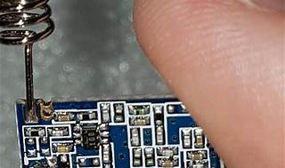

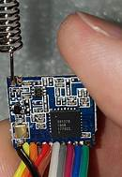

Explore

**LoRa** (Long Range Radio) is an **RF modulation technology** designed specifically for **long-range, low-power communications** in the context of **Internet of Things (IoT)** and **machine-to-machine (M2M) networks**. [It enables communication over distances of up to **10 miles (15 kilometers) or more in rural areas** and up to **three miles (five kilometers) in urban areas**, while maintaining ultra-low power requirements for battery-operated devices that can last for years1](https://lora-developers.semtech.com/documentation/tech-papers-and-guides/lora-and-lorawan)[2](https://www.digikey.in/en/maker/tutorials/2016/introduction-to-lora-technology).

Here are **five reference links** where you can learn more about LoRa technology:

1. [**LoRa and LoRaWAN: Technical overview**](https://lora-developers.semtech.com/documentation/tech-papers-and-guides/lora-and-lorawan): This document provides a detailed technical overview of LoRa and LoRaWAN, including range, power efficiency, and deployment considerations[1](https://lora-developers.semtech.com/documentation/tech-papers-and-guides/lora-and-lorawan).
2. [**Introduction to LoRa Technology**](https://www.digikey.in/en/maker/tutorials/2016/introduction-to-lora-technology): DigiKey Electronics offers an introductory tutorial on LoRa technology, covering its development, applications, and benefits[2](https://www.digikey.in/en/maker/tutorials/2016/introduction-to-lora-technology).
3. [**LoRa - Wikipedia**](https://en.wikipedia.org/wiki/LoRa): Wikipedia’s article on LoRa provides an overview of its history, spread spectrum modulation techniques, and patents[3](https://en.wikipedia.org/wiki/LoRa).
4. [**Semtech LoRa Technology Overview**](https://www.semtech.com/lora/): Semtech, the company behind LoRa, offers an overview of LoRa technology, emphasizing its role in connecting sensors to the cloud for IoT applications[4](https://www.semtech.com/lora/).
5. **LoRaWAN Academy**: The LoRaWAN Academy provides free online courses and resources to learn about LoRaWAN, network architecture, and deployment best practices.

Feel free to explore these resources to deepen your understanding of LoRa technology! 🌐🔗